CSE 564 Visualization and Visual Analytics - Lab2 Report

Student: Bo (Bryan) Cao SBU ID: 112130213

Email: [bo.cao.1@stonybrook.edu](mailto:bo.cao.1@stonybrook.edu)or [boccao@cs.stonybrook.edu](mailto:boccao@cs.stonybrook.edu)

**Demo**

Video: <https://youtu.be/QDyNf82vi28> & <https://youtu.be/-vaRWggNbiw>

**Environment**

Python: 3.7.0, D3: v5, jQuery: 3.3.1

**Running the Code**

In the terminal, locate to the directory **112130213_BryanBoCao_lab02_CSE564**, run **python3 app.py**, and enter <http://127.0.0.1:5000/> in the address field of a browser. I use Chrome Version 72.0.3626.121 (Official Build) (64-bit).

**File Structure**

All files include **1) app.py,** **2) templates/index.html,** and **3) College.csv,** where **1) app.py** is the server code to run in the backend and **2) index.html** is the file in the frontend to visualize data sent from backend; **3) College.csv** is the dataset downloaded from the college dataset from <https://vincentarelbundock.github.io/Rdatasets/datasets.html>, the original College dataset includes 777 data points, 18 dimensions.

Note that there are 3 main kinds of data: 1) all data, 2) sampled data and 3) stratified sampled data. Stratified sampled data is written as “ss data” in the code and in the visualization. All these 3 kinds of data are visualized in all 3 kinds of plots – scree plot, scatter plot and scatter plot matrix.

**Code**

**Backend**

Python is used as the language for backend. The structure of **app.py** is depicted as follows:

*@app.route("/", methods = ['POST', 'GET'])*

*index(), random_sample(), stratified_sample(), my_PCA(), top2_PCA_Vectors(), my_MDS() and compute_scatterplot_matrix().*

When we enter <http://127.0.0.1:5000/> on a browser, a GET request is sent to app.py and it goes into index(), where all the data for visualization is computed, including random_sample(), stratified_sample(), my_PCA(), top2_PCA_Vectors(), my_MDS() and compute_scatterplot_matrix(). random_sample() samples half of the population from all data. In stratified_sample(), clusters are computed by KMeans, the k which locates in the elbow is computed simply by comparing the speed of decrease of distortion - we iterate k from 0 to n, and determine the elbow_k as soon as the difference is less than the threshold 0.05. This elbow_k will also be sent to the frontend to highlight it, which will be shown in the next section. my_PCA() will take data matrix as input and return PCA object that includes PCA-related information and top 3 attributes with highest PCA loadings. The explained variance ratio is in the PCA object. Top 3 attributes are computed by summation square of all the components. top2_PCA_Vectors() simply takes the data as input and returns the matrix with respect to top 2 PCA vectors. my_MDS() takes data as input and returns the embedding MDS matrix, depending on the parameter “dissimilarity” to be Euclidean or Correlation. compute_scatterplot_matrix() is mainly to compute the scatterplot matrix for the convenience of the frontend to visualize. These information is displayed in the backend, such as:

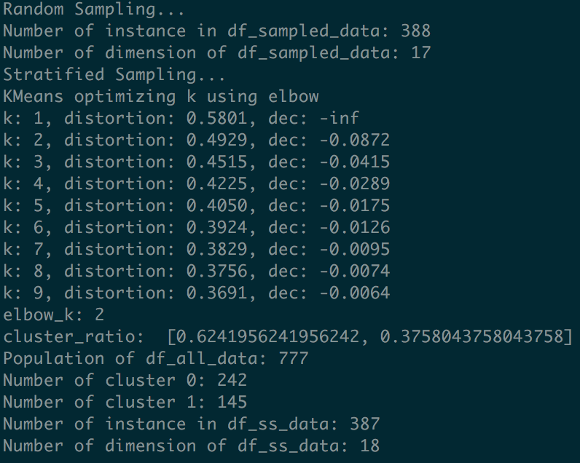 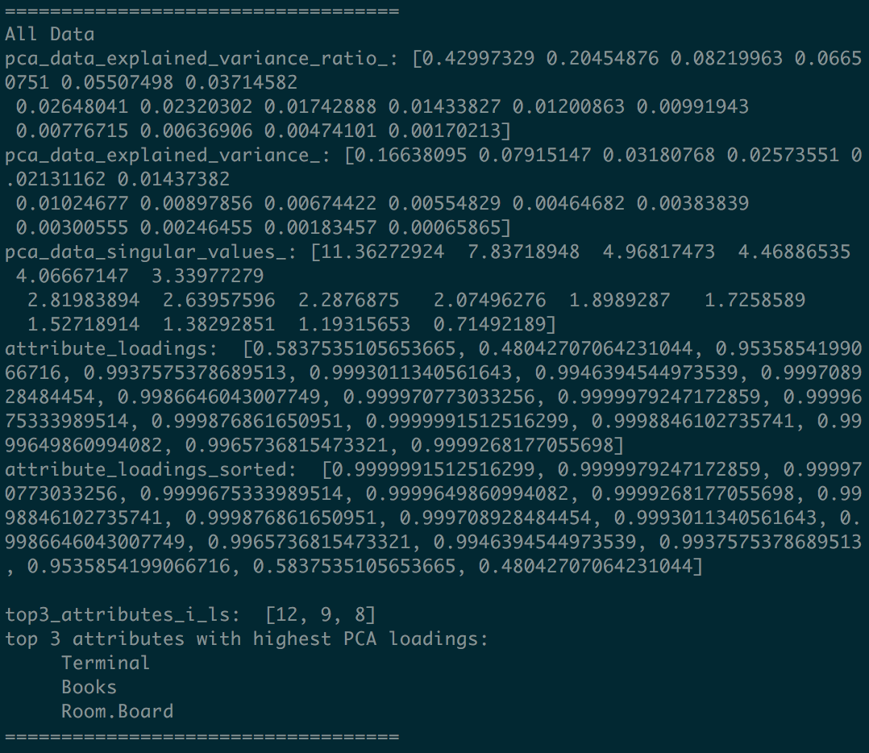

Note that when some data is visualized, users can update the data in the frontend by sending a POST request to the backend, the app.py will do all the computation mentioned above and jsonify the data to be sent to the frontend.

**Frontend**

D3 is used for visualization, Bootstrap is used as the base css and jQuery is used to send GET/POST request to backend to retrieve new data.

When index.html gets the data from backend, it visualizes them in scree plot, scatter plot and scatterplot matrix, including all data, sampled data and stratified sampled data (ss data).

The picture below shows a scree plot for sampled data. Note that the elbow (k=2) is marked and highlighted in a larger red dot. This is done according to elbow_k computed from backend.

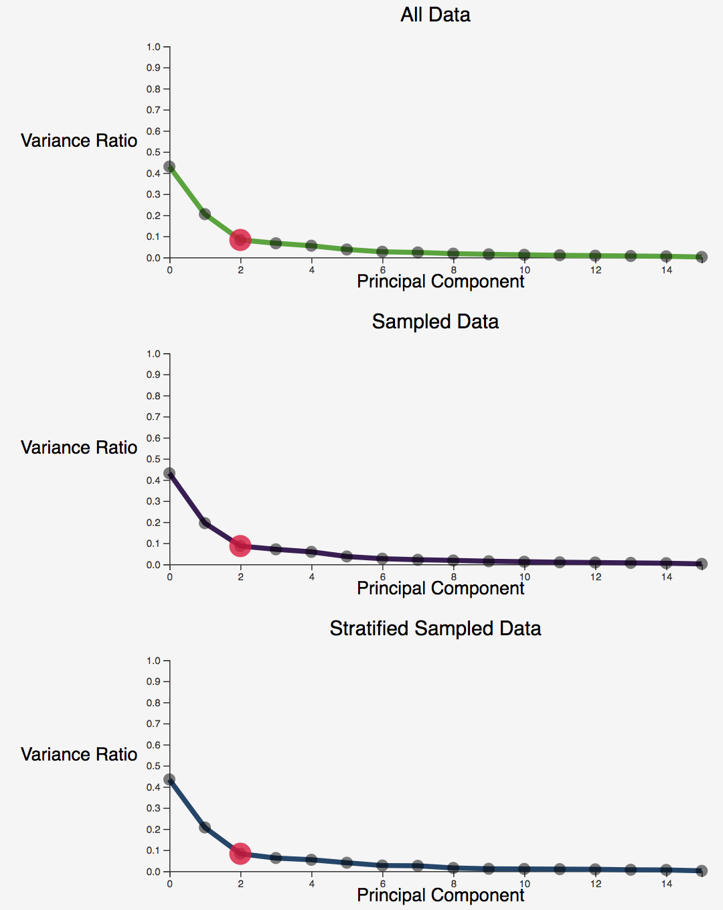

Data for Top 2 PCA Vectors is visualized in 2D scatter plot with origin in the center as shown in the picture below.

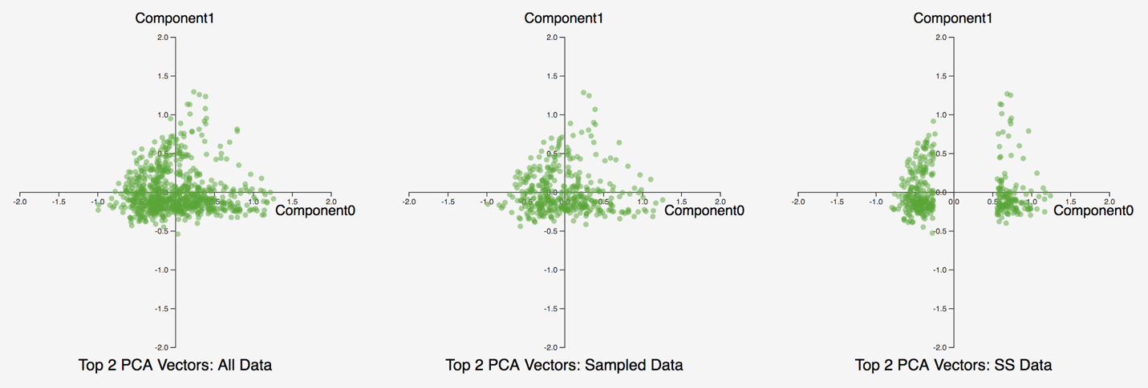

Note that if we resample data, we can see that the chart on the right side is different from the previous one (shown in the picture above and below). However, we can see that the overall shape still remains the same since they were sampled from the same distribution.

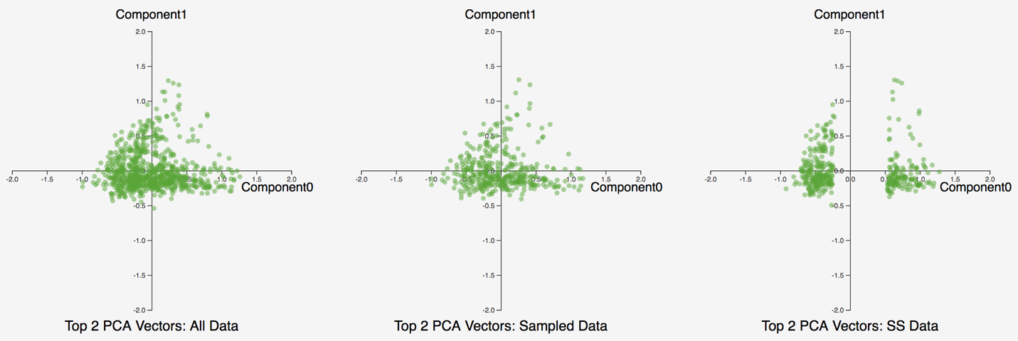

We can also see how stratified sampled data (ss data) introduced the bias in the dataset.

In terms of scatterplot matrix, I made a general scatter_plot() function that can specify scatterplot matrix. In the scatterplot_matrix() method, we iterate through the 3 by 3 matrix of the top 2 attributes computed from the backend and visualize each pair in the corresponding position. The snippet of the cod is shown below:

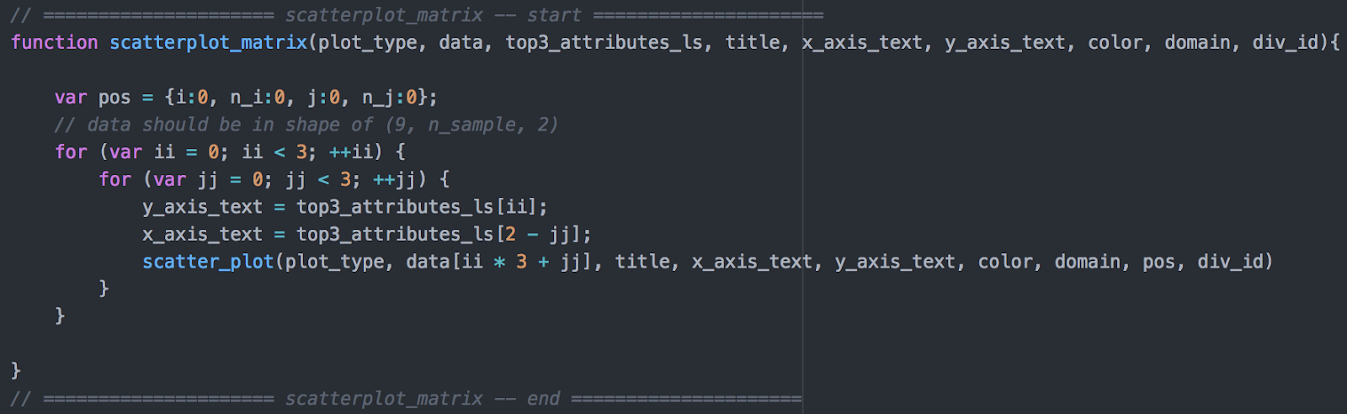

One thing to note is the fade-in fade-out effect for all charts. For instance, if I move my mouse over a specific scatter plot chart, the opacity will be 1.0; if the mouse is moved out of the chart, its opacity will reduced to 0.5 as shown in the right below picture, in which the middle top sub scatterplot is highlighted because user’s mouse is over it while other 8 charts become a little transparent.

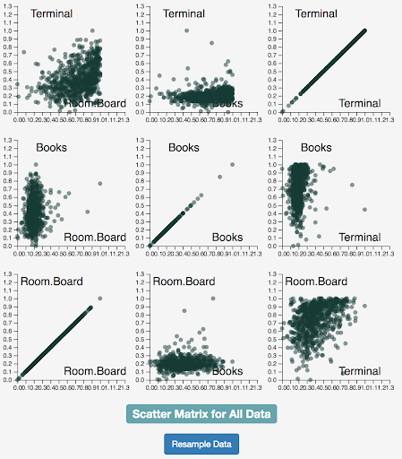 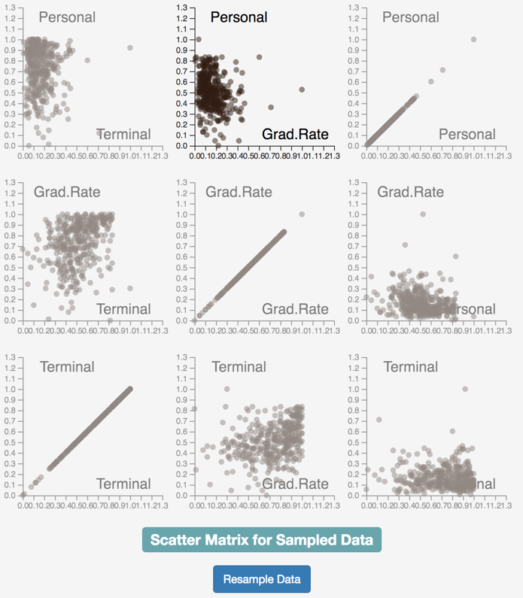

Sending a POST request is done by pressing the 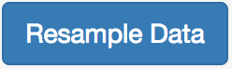button. One interesting thing to note is that when the “Resample Data” button is pressed, all the charts including scree, scatter plot and scatterplot matrix’s opacity will be reduced from 1 to less than 1. The idea is to give user a sense that these charts are inactive that the data is not fresh, so the frontend is waiting for the backend to compute and send new data. Once the frontend receives those data, it will update the visualization with new data. This effect is illustrated in the below picture (left: before resampling, right: after resampling and waiting for the data).

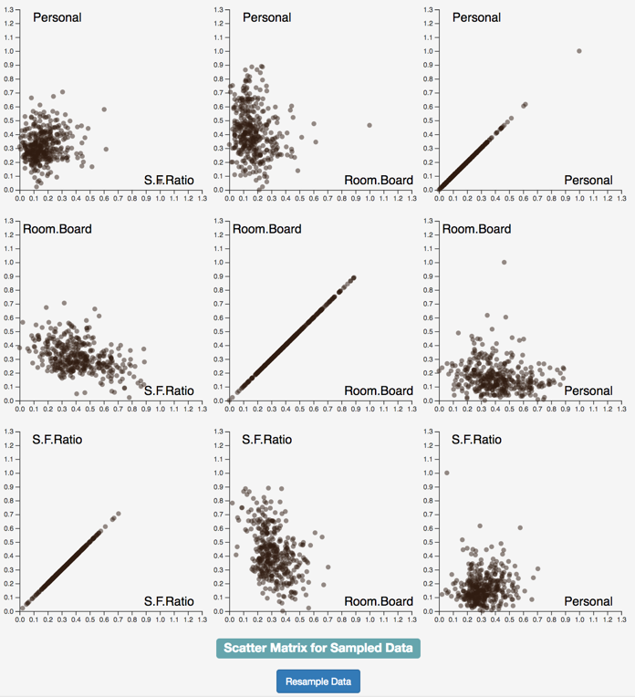 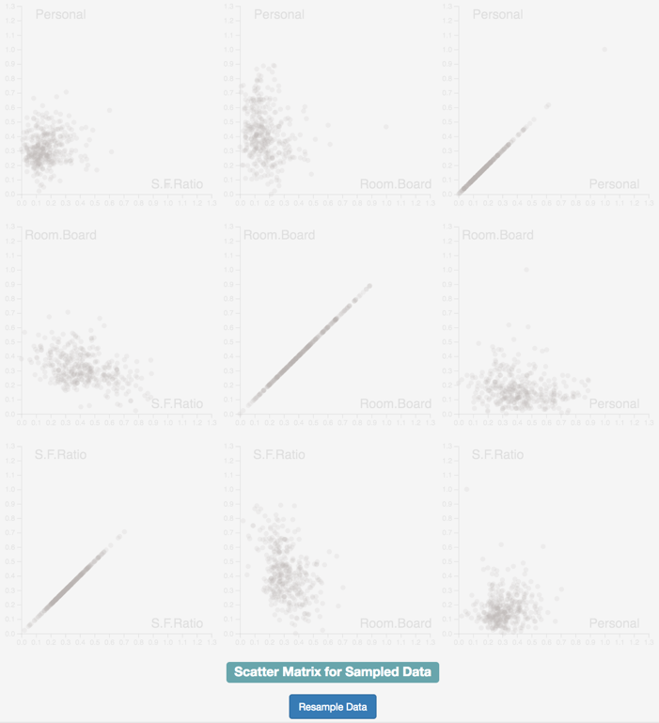

Note that in the post @171 of piazza <https://piazza.com/class/jrms78r329s6vx?cid=171> , professor mentioned that “You are welcome to update your report before midnight today. No harm in that.” so I make this addition report, together with code and video link.